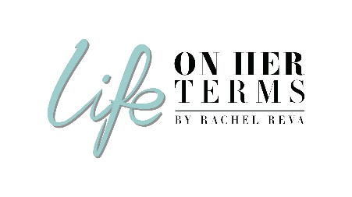

**Life On Her Terms Podcast – Guest Profile**

Thank you for your interest in being featured on my podcast!

Please answer the following questions as best as you can.

This information will help us create the show blurb, your show intro, and other pieces of information for the show.

Once you complete your Guest Profile return to [support@lifeonherterms.com](mailto:support@lifeonherterms.com)

|  |  |
| --- | --- |
| Your Name |  |
| About You / Your Bio (no more than 250 words) |  |
| What are your top THREE lessons that you would like to share?  What are THREE lessons you have learned throughout your life/career (that has supported you in becoming the person you are today) and that you know would be of benefit to our listeners? |  |
|  |
|  |
| Any favourite quotes or scriptures that have helped inspire you? |  |
| Some of the questions I’m likely to ask: | * Your story – where did all of this start? * Some of your greatest achievements / what are you most proud of? * Some of the greatest challenges you have overcome? * Your own role models and people who helped her on her career journey * Lessons you’d share with younger women on career, having a life, and the choices / sacrifices required when you have big ambitions in mind * Looking back to when you started, is there anything you would have done differently in regards to your career or lifestyle? * If you had a radio station where you could speak to EVERYONE in the world for 2 minutes, what would you say? |
| Email |  |
| Phone |  |
| Twitter |  |
| instagram |  |
| website |  |
| linkedin |  |

Our goal is to promote the show globally through our social media channels. We would love you to support us in sharing your show with your global community, once your show goes live.

Here’s where you can find me online. I would love to connect with you!

* My Twitter handle is: @rachdegiorgio
* My Instagram is: @rachreva <https://www.instagram.com/rachreva/>
* My Linkedin is: <https://www.linkedin.com/in/rachel-baugh-degiorgio/>
* Facebook: <https://www.facebook.com/lifeonherterms/>
* Facebook: <https://www.facebook.com/groups/lifeonherterms/>
* [www.lifeonherterms.com](http://www.lifeonherterms.com)
* [www.rachelreva.com](http://www.rachelreva.com)



Please connect with me if we aren’t already part of each other’s community! You can then retweet, regram and share my messages about your show. I will also tag and include you in the posts.

**IMPORTANT NOTE:**

We assume that by completing and returning this Guest Profile, you give your permission for your interview to be recorded and used as part of our normal programming, which will be distributed on the internet. Your show may also be used for promotional purposes and/or information products created by Life On Her Terms Podcast and/or its representatives.

**Please type your name below to confirm you have read and agree with the above.**

**I agree: __________­­­­­­­­­­­­­­­­­_  
  
Thank you!**

Life On Her Terms Team

*Once you complete your Guest Profile please return to* [*support@lifeonherterms.com*](mailto:support@lifeonherterms.com)

*Thank you! I look forward to our interview!*

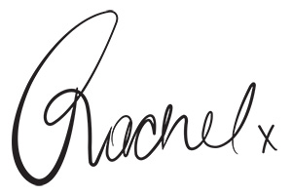

*Rachel Reva, Host of ‘Life On Her Terms’ Podcast*